Sanjeev Agrawal Global Educational University, Bhopal



**Lab File of**

**Infrastructure Solution On Cloud**

**Course Code: CA21B501P**

**Prepared by:**

**Aditya Nair**

**Enrollment No. – 22BCA3CCM10005**

**School of Computer Application**

**Session: Autumn 2023-24**

**Index**

|  |  |  |  |  |
| --- | --- | --- | --- | --- |
| **Sr. No.** | **Aim of Experiment** | **Scheduled date** | **Actual date** | **Remarks** |
| 1 | Create and document the process of creating a windows azure account. |  |  |  |
| 2 | Create a virtual machine from available releases of windows server images. |  |  |  |
| 3 | Create a virtual machine using the option “quick Create”. |  |  |  |
| 4 | Create a custom VM and Capture the image. |  |  |  |
| 5 | Create a vm from a captured image |  |  |  |
| 6 | Add a VMs to a cluster and deploy load balancer on the same. |  |  |  |
| 7 | Create and publish / host a webpage in windows azure. |  |  |  |
| 8 | Create a website using Visual studio. |  |  |  |
| 9 | Create a SQL server DB , Create tables and add data to the table. |  |  |  |
| 10 | Test basic sql commands on the table created in the previous step. |  |  |  |
| 11 | Migrate an on premise DB to Azure. |  |  |  |

# Experiment-1

**Aim:** Create and document the process of creating a windows azure account.

**Practical Steps:** Steps for Microsoft Azure account creation are as follows:

1. 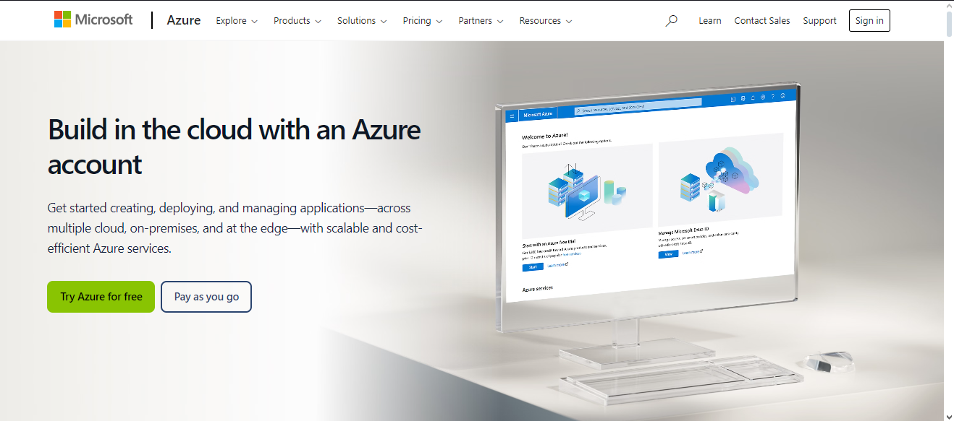**Step 1:** Visit the Azure Portal and click on "Start free."

**Fig 1.1 – Azure Portal**

1. 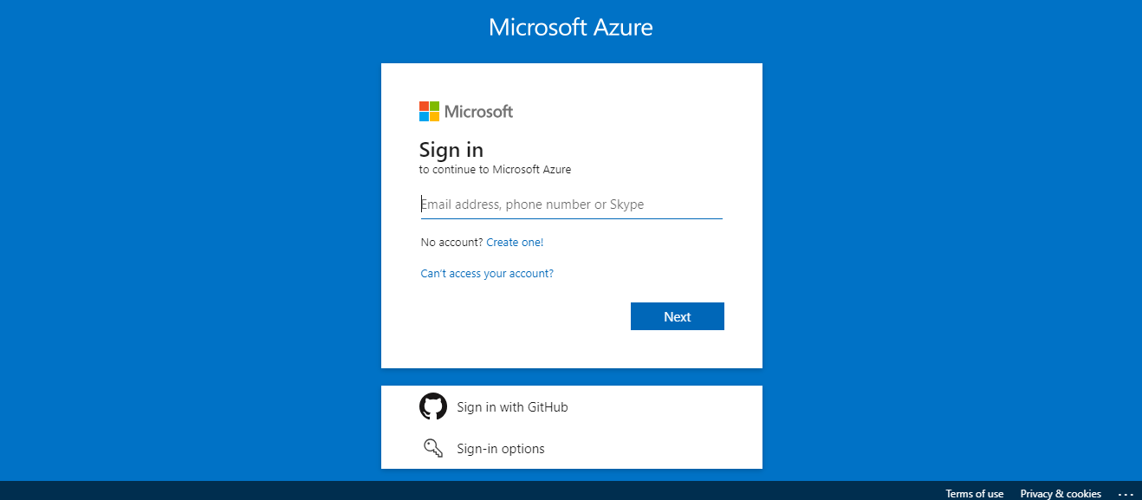**Step 2:** Sign in with a Microsoft account. If you don’t have one, create a new account.

**Fig 1.2 – Microsoft Sign in Page**

1. 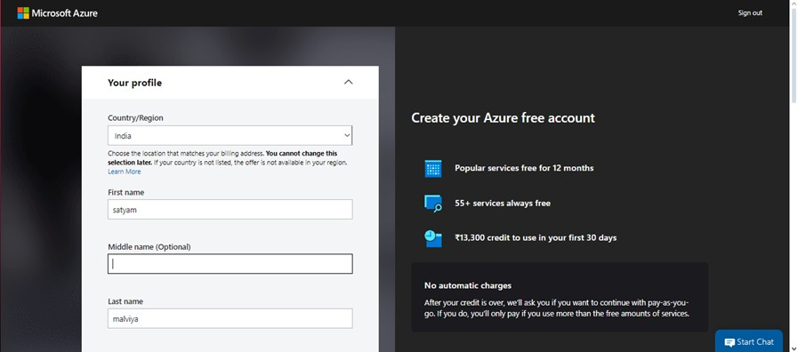**Step 3:** Fill in your personal details including name, email, phone number, etc.

**Fig 1.3 – Microsoft Azure Register Portal**

1. **Step 4:**
   * Verify your identity via a mobile phone number and credit card (no charges for free services).
2. **Step 5:**
   * Agree to the terms and conditions.
3. **Step 6:**
   * 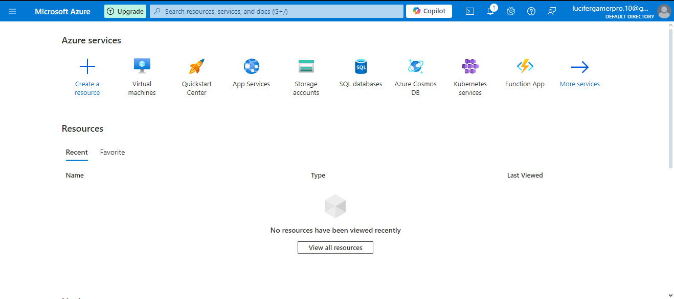Once verified, you will have access to the Azure portal where you can manage your resources.

**Fig 1 – Microsoft Azure Management Console**

**Result:** A verified Azure account with access to cloud services.

# Experiment-2

**Aim:** Create a Virtual Machine from Available Releases of Windows Server Images.

## Practical Steps: Creating Virtual Machine:

## Step 1: Log in to your Azure account on the Azure portal.

## Fig 2.1 - Azure portal

## Step 2: In the left-hand panel, select Virtual Machines and then click on Create.

## Fig 2.2 – Virtual Machine Management Portal

## Step 3: In the Create a virtual machine wizard, choose Azure Virtual Machine.

## Fig 2.3 – Azure Virtual Machine Selection

## Step 4: Select a specific version (e.g., Windows Server 2019, Windows Server 2022, etc.).

## Fig 2.4 – Select Windows Image

## Step 5: Configure the following settings:

## Region (Data Center location)

## Size (VM size based on CPU, RAM)

## Administrator account (create a user and password)

## Network settings (can use default settings for public IP, VNet)

## Fig 2.5 – Configure Virtual Machine

## Step 6: Click on Review + Create and then Create.

## Fig 2.6 – Review and Create Screen

## Step 7: Wait for the deployment to finish and access the VM via Remote Desktop Protocol (RDP).

## Fig 2.7 – Virtual Machine Management Screen

## Fig 2.8 – Virtual Machine

**Result:** A fully deployed and accessible Windows Server VM.